Name:B.Pooja

Batch:41

Roll-No:2303A52141

**TASK 1**: Sentiment Classification for Customer Reviews

Promt:

Prepare 6 short customer reviews mapped to sentiment labels.Design a Zero-shot prompt to classify sentiment.Design a One-shot prompt with one labeled example.Design a Few-shot prompt with 3–5 labeled examples. Compare the outputs and discuss accuracy differences.

**CODE**:

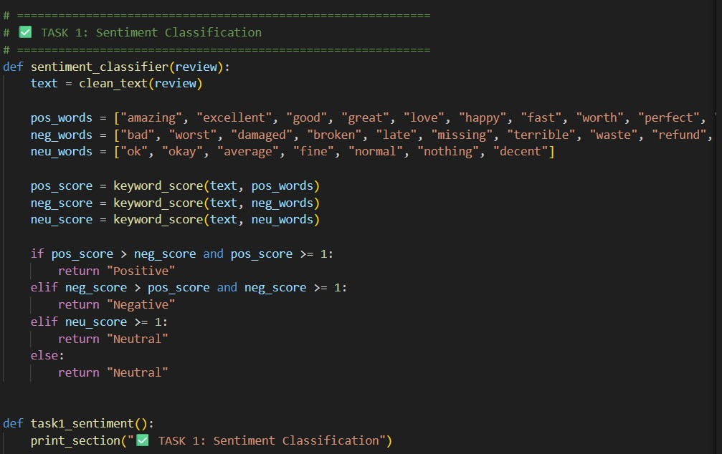

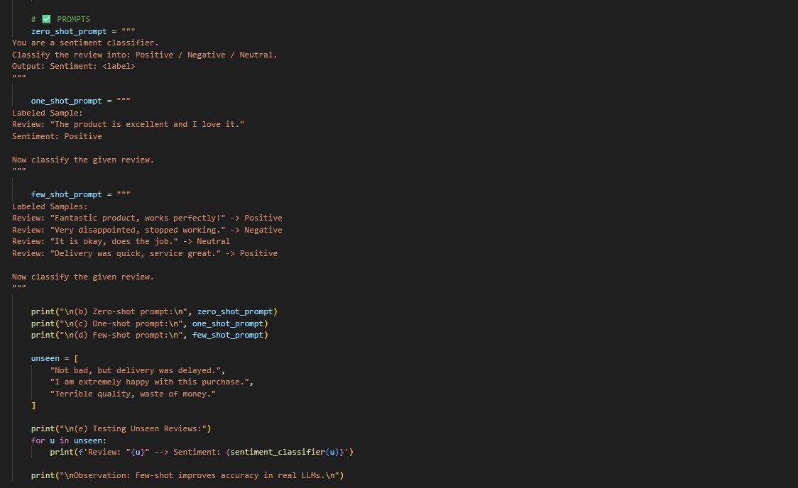

**OUTPUT:**

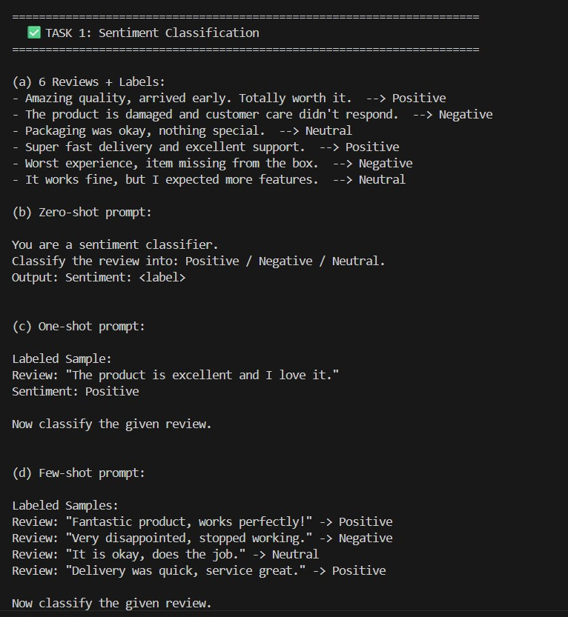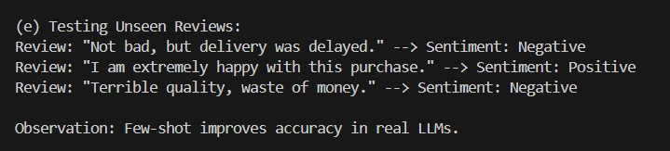

**Explanation:**

This task helps classify customer reviews as Positive, Negative, or Neutral.It is useful for improving product quality and customer satisfaction.Few-shot prompting gives better accuracy for unclear reviews.

**TASK 2:** Email Priority Classification

Prompt:

Create 6 sample email messages with priority labels. Perform intent classification using Zero-shot prompting. Perform classification using One-shot prompting. Perform classification using Few-shot prompting. Evaluate which technique produces the most reliable results and why.

**CODE:**

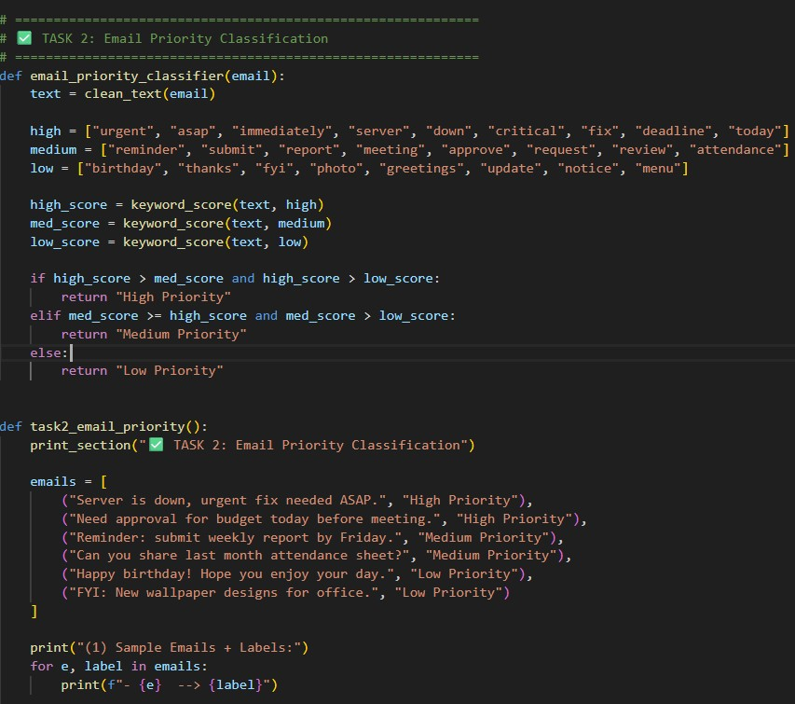

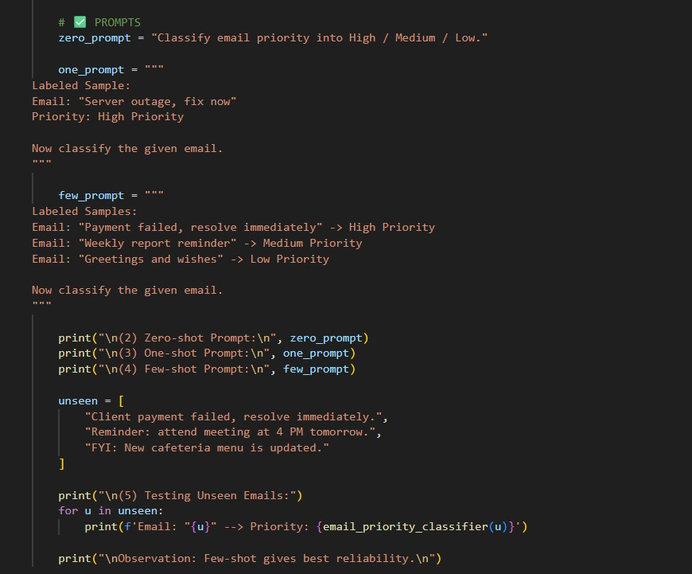

**OUTPUT:**

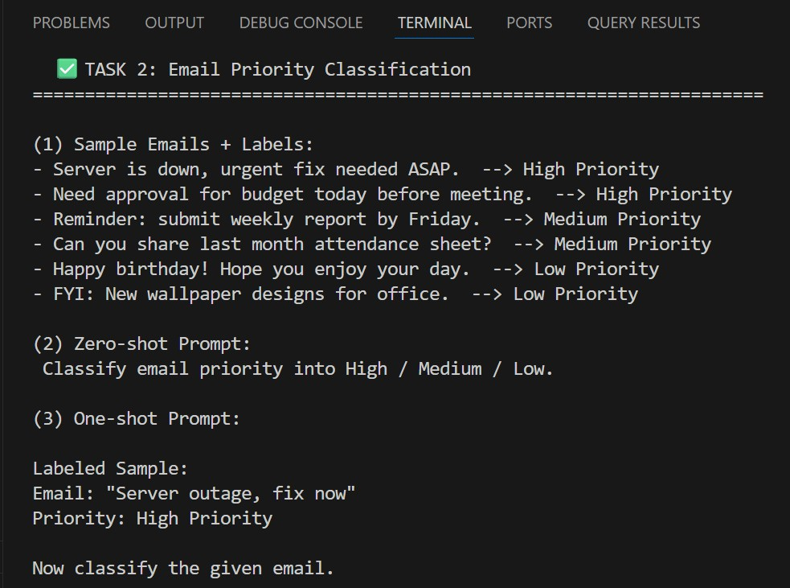

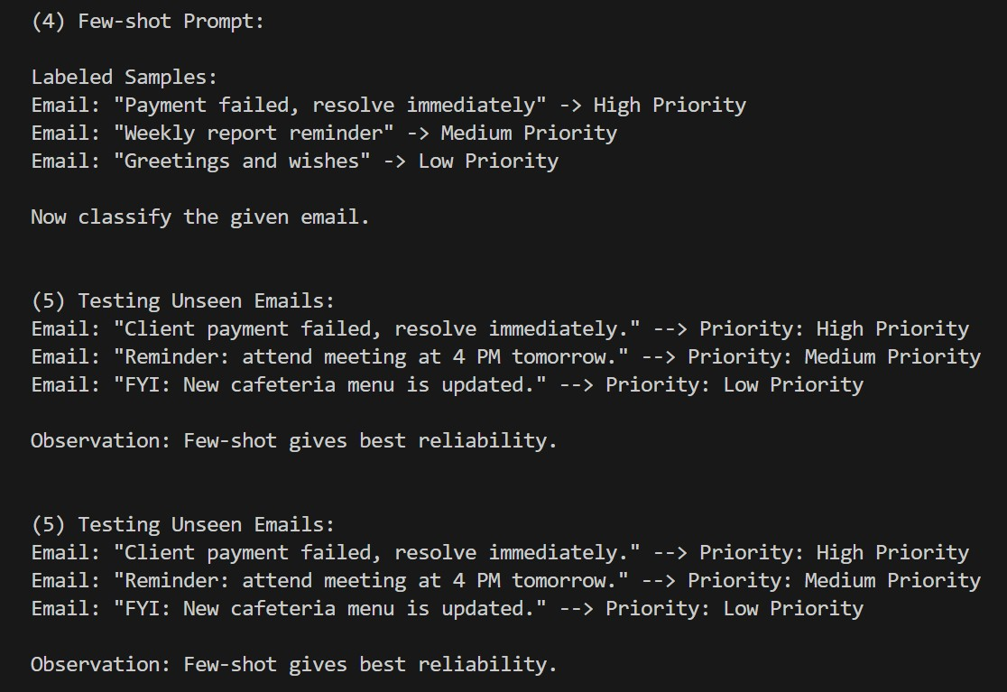

**Explanation:**

This task helps automatically prioritize emails into High, Medium, or Low.It ensures urgent issues are handled quickly without delay.Few-shot prompting gives the most reliable priority results.

TASK 3: Student Query Routing

Prompt:

Create 6 sample student queries mapped to departments.Implement Zero-shot intent classification using an LLM.Improve results using One-shot prompting.Further refine results using Few-shot prompting.Analyze how contextual examples affect classification accuracy.

**CODE:**

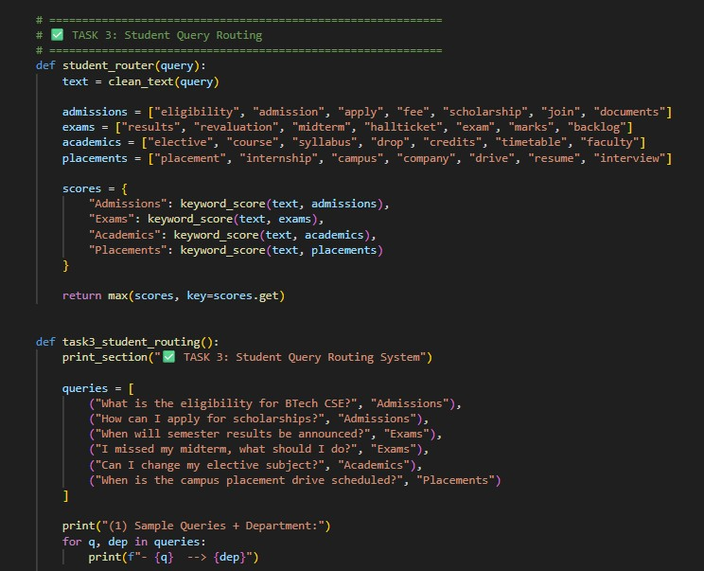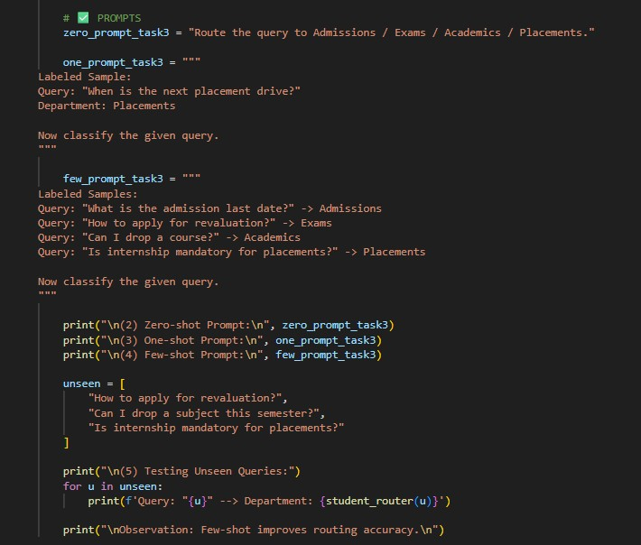

**OUTPUT:**

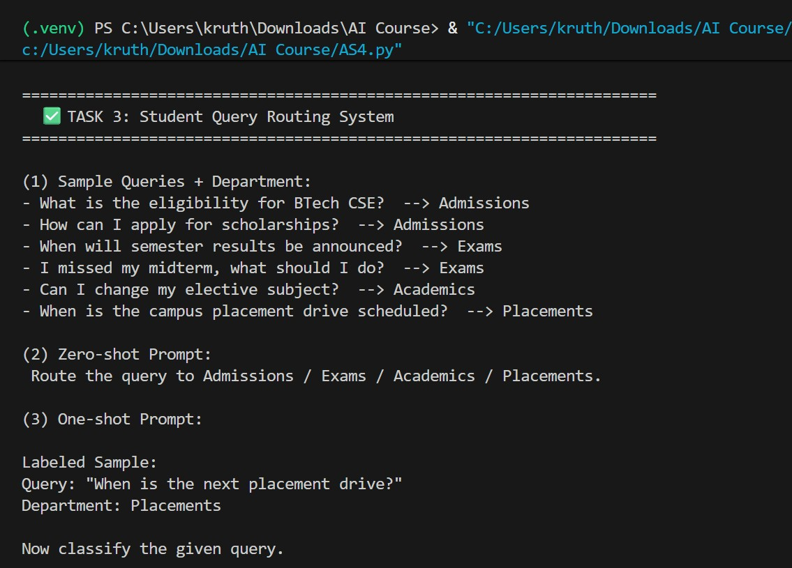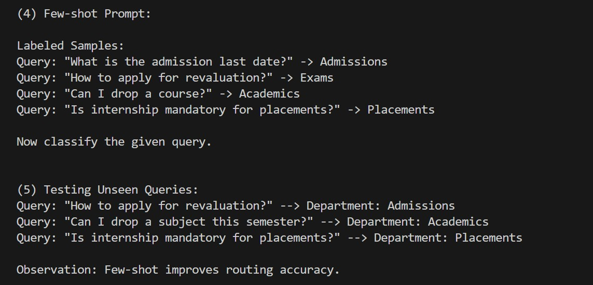

**Explanation:**

This task routes student questions to the correct department.It reduces manual workload and gives faster responses.Few-shot examples improve routing accuracy.

**TASK 4:** Chatbot Question Type Detection

Promt:

Prepare 6 chatbot queries mapped to question types. Design prompts for Zero-shot, One-shot, and Few-shot learning. Test all prompts on the same unseen queries. Compare response correctness and ambiguity handling. Document observations.

**CODE:**

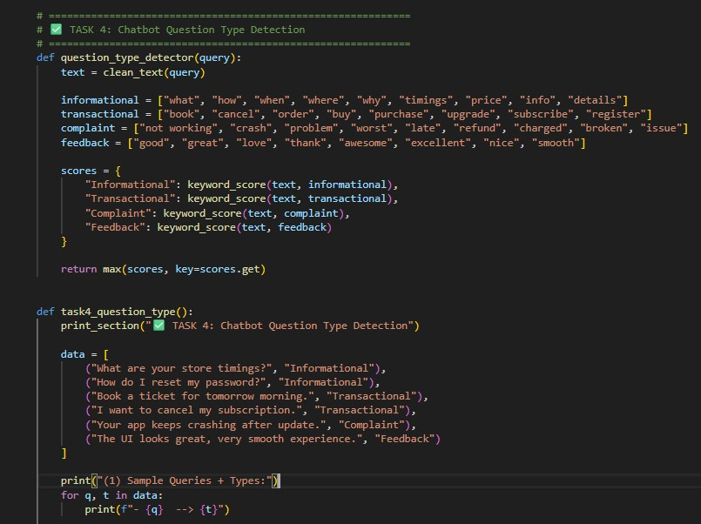

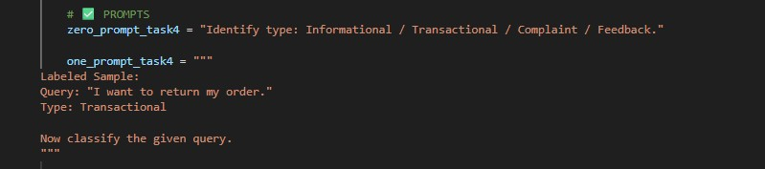

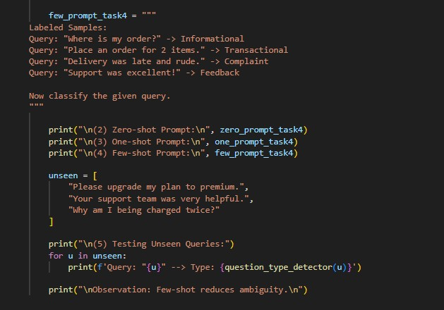

**OUTPUT:**

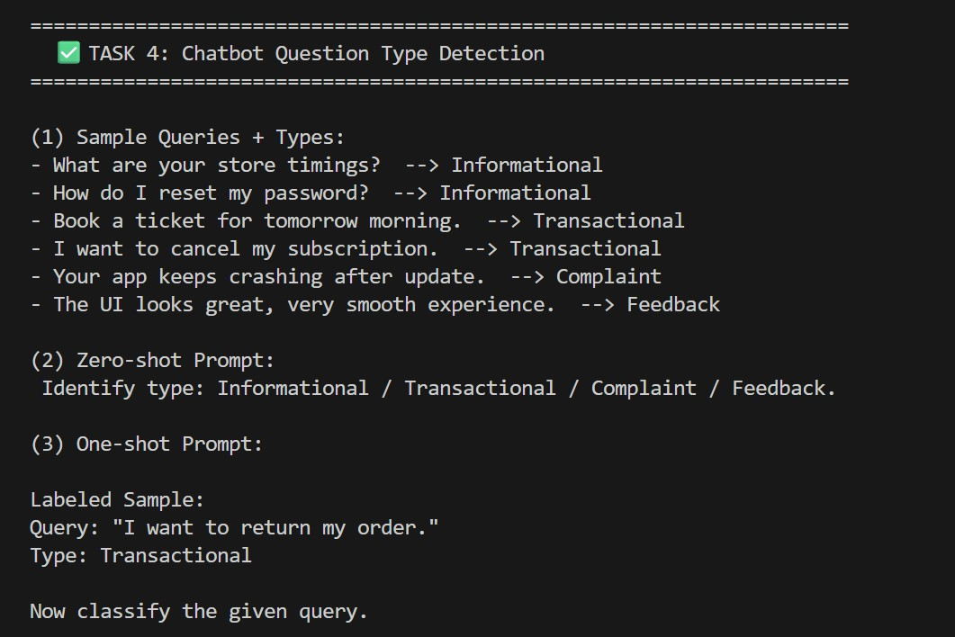

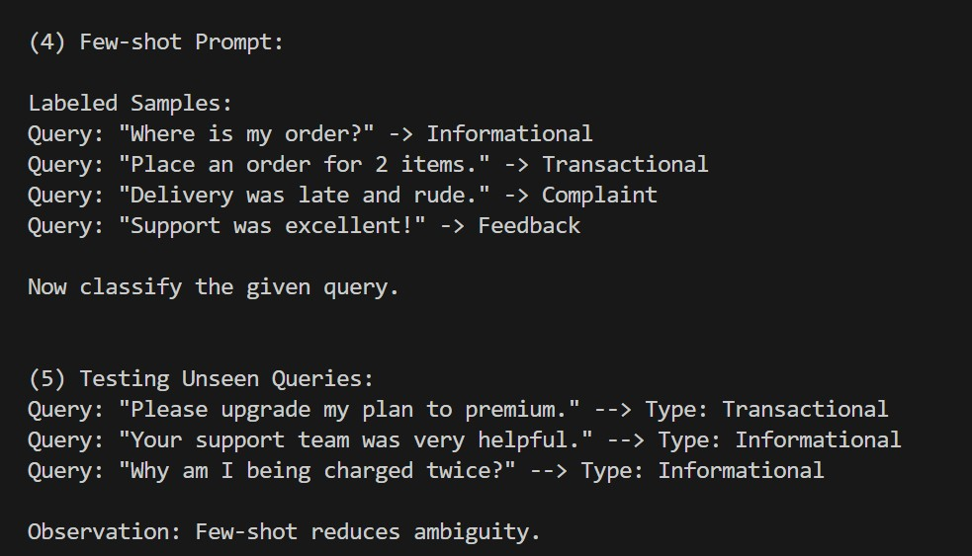

**Expnataion:**

This task identifies query type: informational, transactional, complaint, or feedback. It helps the chatbot respond correctly based on user intent.Few-shot reduces confusion between similar query types.

**TASK 5:** Emotion Detection Scenario:

**Promt:**

Create labeled emotion samples.Use Zero-shot prompting to identify emotions.Use One-shot prompting with an example. Use Few-shot prompting with multiple emotions. Discuss ambiguity handling across techniques.

**CODE:**

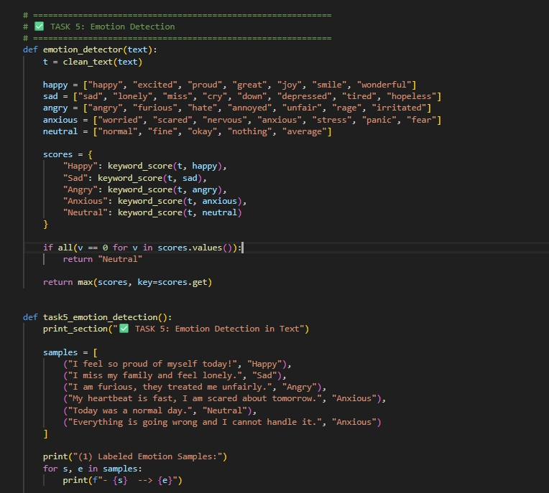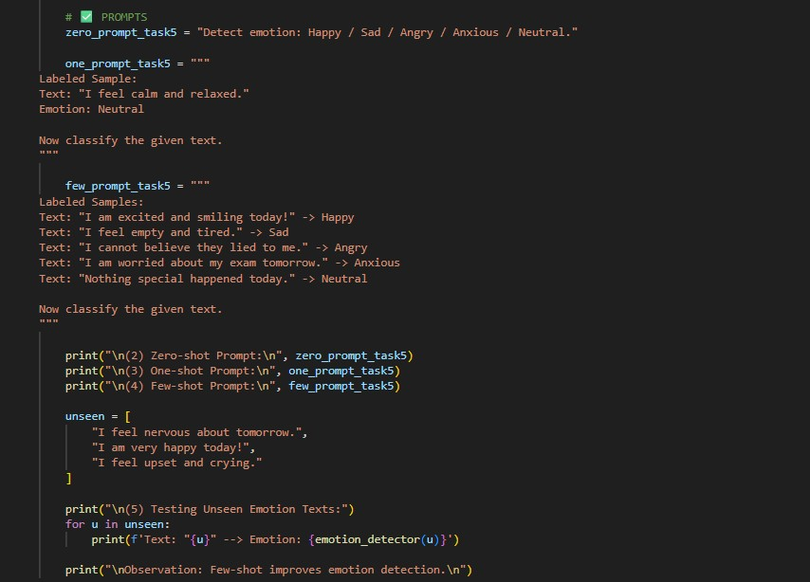

**OUTPUT:**

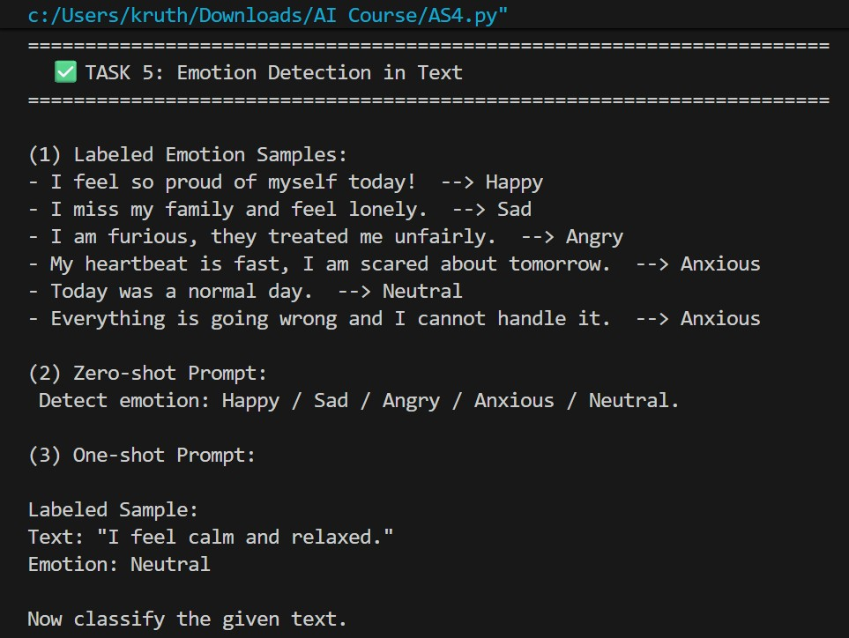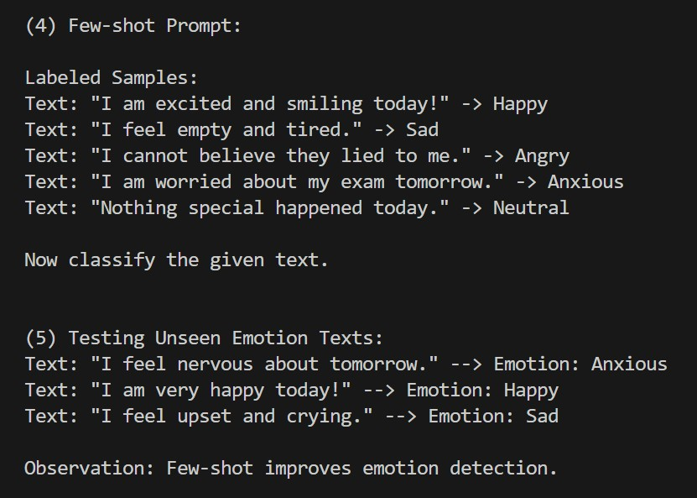

**Explanation:**

This task detects emotions from user text for mental-health support.It helps provide correct guidance and empathetic responses.Few-shot handles mixed emotions better than zero-shot.